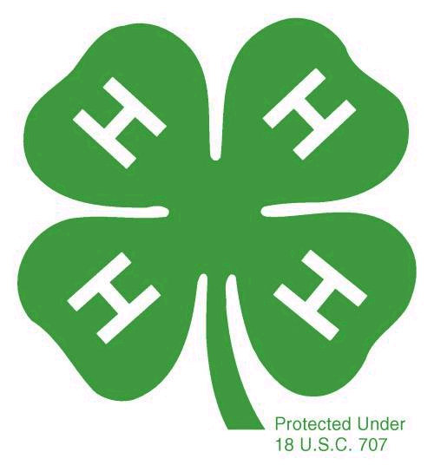
Member Name:

4-H Year: ____________________________

East Hills 4-H Club
Super Member Award
Primary Members (5-8 years old)

All club members qualify for this yearly award by completing 8 of the 12 items listed. Check off the numbers and add the date(s) next to the items. Place this sheet in front of your PDR (Personal Development Report) in your Record Book.
Earn your 100% attendance pin by attending all club meetings (attending an Officers’ meeting counts as attending a club meeting)
Wear your 4-H t-shirt to at least 5 monthly community club meetings.
Dates of meetings:

Write 2 news articles for our newsletter.
Titles and Dates:

Give two talks or project reports at the club meeting that have been prepared prior to the meeting
Participate in three hours of community service.
Description and # of hours:

Attend two 4-H events other than club and project meetings (i.e. field days, Skate Night, etc.)
Events:

Hand in a completed Record Book on time
Attend 80% of your project meetings.
Complete two projects with 80% attendance and submit a complete Record Book.
Bring a friend or guest (other than parents) to a club meeting.
Come early to 2 club meetings and help to set up chairs and tables and decorate OR stay late to help clean up after the meeting is finished.
Dates

Enter an item into the Alameda County Fair (if you do two items, this counts for 2 credits for a Super Member award).
Name of entry:

Member’s Signature: _____________________________________________________

Parent’s Signature: _______________________________________________________

