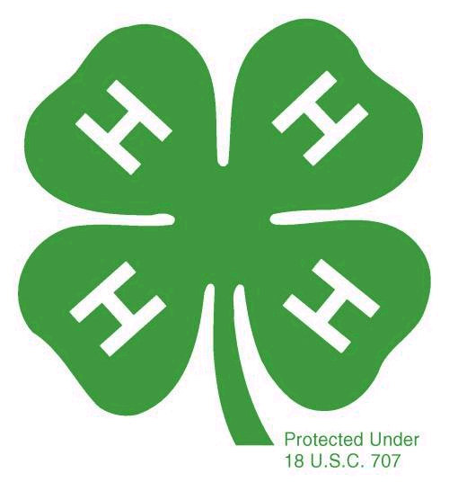
Member Name: ____________________________

4-H Year: ____________________________

East Hills 4-H Club
Super Member Award
Junior and Senior Members

All club members qualify for this yearly award by completing 12 of the 16 items listed. Check off the numbers and add the date(s) next to the items. Place this sheet in front of your PDR (Personal Development Report) in your Record Book.
Earn your 100% attendance pin. (attend all club meetings – attending an Officers’ meeting can count as attending the club meeting for that month).
Wear your 4-H t-shirt to at least 5 monthly community club meetings.
Dates:

Exhibit at one event outside the club (County Fair, State Fair, any Field Day, or Skit Night)
Attend one Officer’s meeting during the year and participate in the discussions
Dates:
Write 3 news articles for our newsletter. (The 3 articles must be written over at least two separate newsletters.)
Dates:
Give two talks or project reports at the club meeting that have been prepared prior to the meeting.
Dates:
Participate in seven hours of community service activities.
Description/# hours:

Perform a club or county service (hold an office, be a Junior or Teen leader, be a room host, help organize an event, act as MC/judge at an event, give a talk at a service club, represent 4-H in a community program, etc.)
Description:
Present at County Presentation Day, Sectional/Regional, or State Presentation Day
Attend three 4-H events other than club and project meetings (i.e. field days, Skate Night, etc.)
Descriptions:

Participate in the Cake Booth at least one shift during the County Fair.
Hand in a completed Record Book on time, including the PDR (Personal Development Report), all project report forms and a personal 4-H story.
Attend 80% of all of your project meetings.
Complete two projects with 80% attendance and submit completed project report forms.
Bring a friend or guest (other than parents) to a club meeting.
Publicize our club’s name and code for Farm Fresh to You fundraising (people who use Farm Fresh can enter our code to earn us a small portion of their orders)

Member’s Signature: _____________________________________________________

Parent’s Signature: _______________________________________________________

